Production-Grade CI/CD Pipeline using Jenkins Multibranch & GitOps Project

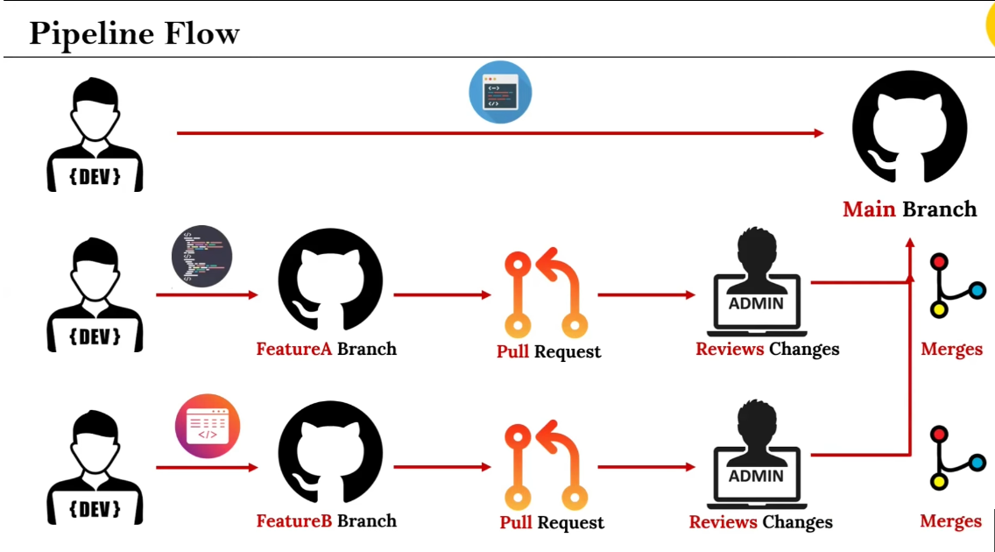

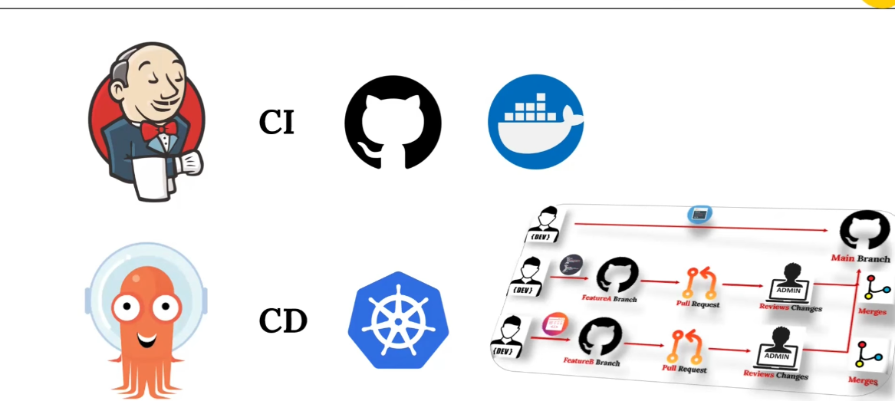

🚀 Production-Grade CI/CD Pipeline with Jenkins Multibranch & GitOps

📌 Table of Contents
- Project Overview
- Architecture
- Technologies Used
- Prerequisites
- Project Structure
- Setup Instructions
- CI/CD Workflow
- Feature Branch Strategy
- Deployment Process
- Monitoring and Access
- Key Learning Points
- Troubleshooting
- Best Practices
- Contributing

📌 Project Overview
This project demonstrates a production-grade CI/CD pipeline that implements modern DevOps practices using Jenkins Multibranch Pipeline, Docker containerization, Kubernetes orchestration, and GitOps principles with ArgoCD.
The pipeline automates the entire software delivery lifecycle from code commit to production deployment, showcasing how enterprise teams build, test, and deploy applications efficiently and reliably.
What Makes This Production-Grade?
✅ Multi-branch support - Automatic pipeline creation for feature branches
✅ Pull Request workflow - Code review before merge to main
✅ Automated testing - CI pipeline validates code quality
✅ Container-based deployment - Consistent environments across stages
✅ GitOps principles - Infrastructure and application state managed through Git
✅ Automated sync - ArgoCD continuously monitors and deploys changes
✅ Cloud-native - Deployed on AWS EKS for scalability and reliability

🏗️ Architecture
┌─────────────────────────────────────────────────────────────────┐
│ Developer │
└────────────────────┬────────────────────────────────────────────┘
│
▼
┌─────────────────────────────────────────────────────────────────┐
│ GitHub Repository │
│ ┌──────────────┐ ┌──────────────┐ ┌──────────────┐ │
│ │ Feature A │ │ Feature B │ │ Main │ │
│ │ Branch │ │ Branch │ │ Branch │ │
│ └──────────────┘ └──────────────┘ └──────────────┘ │
└────────────────────┬────────────────────────────────────────────┘
│ Webhook
▼
┌─────────────────────────────────────────────────────────────────┐
│ Jenkins Multibranch Pipeline (CI) │
│ ┌──────────┐ ┌──────────┐ ┌──────────┐ ┌──────────┐ │
│ │ Checkout│→ │ Build │→ │ Test │→ │ Docker │ │
│ │ Code │ │ & Lint │ │ Code │ │ Build │ │
│ └──────────┘ └──────────┘ └──────────┘ └──────────┘ │
└────────────────────┬────────────────────────────────────────────┘
│
▼
┌─────────────────────────────────────────────────────────────────┐
│ DockerHub Registry │
│ Tagged Images: app:v1.0.0, app:v1.0.1 │
└────────────────────┬────────────────────────────────────────────┘
│
▼
┌─────────────────────────────────────────────────────────────────┐
│ Git Repository (K8s Manifests Updated) │
│ deployment.yaml (image: app:v1.0.1) │
└────────────────────┬────────────────────────────────────────────┘
│ ArgoCD Monitors
▼
┌─────────────────────────────────────────────────────────────────┐
│ ArgoCD (GitOps Controller - CD) │
│ Auto-Sync Enabled | Health Check │
└────────────────────┬────────────────────────────────────────────┘
│ Deploy
▼
┌─────────────────────────────────────────────────────────────────┐
│ AWS EKS Cluster │
│ ┌──────────────────────────────────────────────────────┐ │
│ │ Namespace: production │ │
│ │ ┌─────────────┐ ┌─────────────┐ ┌─────────────┐ │ │
│ │ │ Pod 1 │ │ Pod 2 │ │ Pod 3 │ │ │
│ │ │ app:v1.0.1 │ │ app:v1.0.1 │ │ app:v1.0.1 │ │ │
│ │ └─────────────┘ └─────────────┘ └─────────────┘ │ │
│ │ │ │
│ │ ┌──────────────────────────────────────────────┐ │ │
│ │ │ LoadBalancer Service │ │ │
│ │ └────────────────┬─────────────────────────────┘ │ │
│ └───────────────────┼─────────────────────────────────┘ │
└────────────────────┬─┴─────────────────────────────────────────┘
│
▼
🌐 Public Endpoint (External URL)

🛠️ Technologies Used
Technology | Version | Purpose
Jenkins | 2.x+ | Continuous Integration server with Multibranch Pipeline support
Docker | 20.x+ | Application containerization and image building
DockerHub | - | Container image registry for storing Docker images
Kubernetes | 1.25+ | Container orchestration platform
AWS EKS | - | Managed Kubernetes service on AWS
ArgoCD | 2.x+ | GitOps continuous delivery tool for Kubernetes
GitHub | - | Source code management and version control
Python | 3.9+ | Application runtime (Flask/FastAPI)
YAML | - | Kubernetes manifests and pipeline definitions

📋 Prerequisites
Before you begin, ensure you have the following:
Required Tools
- ✅ Git installed and configured
- ✅ Docker Desktop or Docker Engine
- ✅ AWS CLI configured with appropriate credentials
- ✅ kubectl installed and configured
- ✅ GitHub account with repository access
- ✅ DockerHub account
Required Access
- ✅ Jenkins server (self-hosted or cloud)
- ✅ AWS account with EKS cluster permissions
- ✅ ArgoCD installed on Kubernetes cluster
- ✅ GitHub webhook configuration permissions
Knowledge Prerequisites
- Basic understanding of Git workflows
- Familiarity with Docker and containerization
- Knowledge of Kubernetes concepts
- Understanding of CI/CD principles

📁 Project Structure
Production-Grade-CI-CD-Pipeline-using-Jenkins-Multibranch-GitOps/
│
├── FeatureA Branch Code/ # Feature A specific code and configurations
│ └── app.py # Modified application for Feature A
│
├── FeatureB Branch Code/ # Feature B specific code and configurations
│ └── app.py # Modified application for Feature B
│
├── argocd/ # ArgoCD configuration files
│ ├── application.yaml # ArgoCD Application definition
│ └── project.yaml # ArgoCD Project definition (optional)
│
├── k8s/ # Kubernetes manifests
│ ├── deployment.yaml # Kubernetes Deployment configuration
│ ├── service.yaml # Kubernetes Service (LoadBalancer)
│ └── namespace.yaml # Namespace definition (optional)
│
├── .gitignore # Git ignore patterns
├── Dockerfile # Docker image build instructions
├── Jenkinsfile # Jenkins pipeline definition
├── app.py # Main Python application
├── requirements.txt # Python dependencies (if applicable)
└── README.md # Project documentation

🚀 Setup Instructions
Step 1: Clone the Repository
git clone https://github.com/juhisinha422/Production-Grade-CI-CD-Pipeline-using-Jenkins-Multibranch-GitOps.git
cd Production-Grade-CI-CD-Pipeline-using-Jenkins-Multibranch-GitOps
Step 2: Setup Jenkins Multibranch Pipeline
- Install Required Plugins in Jenkins:
  - Docker Pipeline
  - Kubernetes
  - Git Plugin
  - Multibranch Pipeline Plugin
  - Credentials Binding Plugin
- Configure Jenkins Credentials:
- Manage Jenkins → Credentials → Global → Add Credentials
  - Add DockerHub credentials (username/password or token)
  - Add GitHub credentials (personal access token)
  - Add AWS credentials for EKS access
- Create Multibranch Pipeline:
- New Item → Multibranch Pipeline → Configure
  - Branch Sources: GitHub
  - Repository URL: Your forked repository
  - Credentials: GitHub token
  - Discover branches: All branches
  - Build Configuration: by Jenkinsfile
- Configure GitHub Webhook:
- Repository Settings → Webhooks → Add webhook
- Payload URL: http://<jenkins-url>/github-webhook/
- Content type: application/json
- Events: Push events, Pull requests
Step 3: Setup AWS EKS Cluster
# Create EKS cluster (if not already created)
eksctl create cluster \
--name production-cluster \
--region us-east-1 \
--nodegroup-name standard-workers \
--node-type t3.medium \
--nodes 3

# Configure kubectl
aws eks update-kubeconfig --name production-cluster --region us-east-1
Step 4: Install and Configure ArgoCD
# Create ArgoCD namespace
kubectl create namespace argocd

# Install ArgoCD
kubectl apply -n argocd -f https://raw.githubusercontent.com/argoproj/argo-cd/stable/manifests/install.yaml

# Expose ArgoCD server
kubectl patch svc argocd-server -n argocd -p '{"spec": {"type": "LoadBalancer"}}'

# Get ArgoCD admin password
kubectl -n argocd get secret argocd-initial-admin-secret -o jsonpath="{.data.password}" | base64 -d

# Get ArgoCD URL
kubectl get svc argocd-server -n argocd
Step 5: Configure ArgoCD Application
# Apply ArgoCD application configuration
kubectl apply -f argocd/application.yaml

# Or create via ArgoCD UI:
# - Application Name: my-app
# - Project: default
# - Sync Policy: Automatic
# - Repository URL: https://github.com/juhisinha422/Production-Grade-CI-CD-Pipeline-using-Jenkins-Multibranch-GitOps
# - Path: k8s
# - Cluster: https://kubernetes.default.svc
# - Namespace: default
Step 6: Deploy Application
# Jenkins will automatically trigger on code push
# Or trigger manually from Jenkins dashboard

# Verify deployment
kubectl get pods -n default
kubectl get svc -n default

# Get application URL
kubectl get svc -o wide

🔄 CI/CD Workflow
Continuous Integration (CI) - Jenkins Pipeline
The Jenkinsfile defines the following stages:
1. Checkout Source Code
├─ Pull latest code from GitHub
└─ Checkout appropriate branch

2. Build & Test
├─ Run unit tests
├─ Code quality checks
└─ Lint Python code

3. Docker Build
├─ Build Docker image
├─ Tag with version number
└─ Scan for vulnerabilities (optional)

4. Push to Registry
├─ Authenticate with DockerHub
└─ Push tagged image

5. Update K8s Manifests
├─ Update deployment.yaml with new image tag
├─ Commit changes to Git
└─ Push to repository
Continuous Deployment (CD) - ArgoCD
ArgoCD handles the deployment automatically:
1. Monitor Git Repository
└─ Watch for changes in k8s/ directory

2. Detect Changes
└─ Compare desired state (Git) vs actual state (cluster)

3. Sync Application
├─ Pull updated manifests
├─ Apply to Kubernetes cluster
└─ Perform rolling update

4. Health Check
└─ Verify pod health and readiness

🌿 Feature Branch Strategy
Creating a Feature Branch
# Create and switch to feature branch
git checkout -b feature/my-new-feature

# Make changes to code
vim app.py

# Commit changes
git add .
git commit -m "Add: New feature implementation"

# Push to GitHub
git push origin feature/my-new-feature
Jenkins Automatic Discovery
- Jenkins automatically detects new branches
- Creates a pipeline job for the new branch
- Triggers build automatically on push
Pull Request Workflow
1. Developer creates PR from feature branch to main
2. Jenkins runs CI pipeline on PR branch
3. Code review by team members
4. Tests pass ✓
5. Merge PR to main
6. Jenkins triggers main branch pipeline
7. Docker image built and pushed
8. K8s manifests updated
9. ArgoCD syncs changes
10. Application deployed to production

🚀 Deployment Process
Manual Deployment
# Build Docker image locally
docker build -t yourusername/app:v1.0.0 .

# Push to DockerHub
docker push yourusername/app:v1.0.0

# Update Kubernetes deployment
kubectl set image deployment/app-deployment app=yourusername/app:v1.0.0

# Or apply manifest
kubectl apply -f k8s/deployment.yaml
Automated Deployment (GitOps)
Simply commit and push changes:
git add .
git commit -m "Update: Application version to v1.0.0"
git push origin main
ArgoCD handles the rest automatically!

📊 Monitoring and Access
Access the Application
# Get LoadBalancer URL
kubectl get svc app-service -o wide

# Access application
curl http://<EXTERNAL-IP>:<PORT>
Monitor ArgoCD
# Access ArgoCD UI
# Use the LoadBalancer URL from installation

# CLI commands
argocd app list
argocd app get my-app
argocd app sync my-app
Monitor Jenkins
- Access Jenkins dashboard: http://<jenkins-url>:8080
- View pipeline logs
- Check build history
- Monitor webhook activity
Monitor Kubernetes
# Check pod status
kubectl get pods -w

# Check pod logs
kubectl logs -f <pod-name>

# Check deployment status
kubectl rollout status deployment/app-deployment

# Check service endpoints
kubectl get endpoints

🎯 Key Learning Points
1. Multibranch Pipeline Benefits
- Automatic pipeline creation for new branches
- Isolated testing environments per branch
- Parallel development without interference
2. GitOps Principles
- Git as single source of truth
- Declarative infrastructure
- Automated synchronization
- Version control for all changes
3. Container Best Practices
- Multi-stage Docker builds
- Image layer optimization
- Security scanning
- Immutable infrastructure
4. Kubernetes Deployment Strategies
- Rolling updates
- Zero-downtime deployments
- Health checks and readiness probes
- Resource management
5. CI/CD Best Practices
- Automated testing at every stage
- Fast feedback loops
- Consistent environments
- Rollback capabilities

🔧 Troubleshooting
Jenkins Pipeline Issues
Problem: Pipeline not triggering on push
# Solution: Verify webhook configuration
# Check Jenkins webhook logs
# Verify GitHub webhook delivery
Problem: Docker build fails
# Solution: Check Jenkins Docker credentials
# Verify Dockerfile syntax
# Check available disk space
ArgoCD Sync Issues
Problem: Application out of sync
# Force sync
argocd app sync my-app --force

# Check sync status
argocd app get my-app

# View sync logs
kubectl logs -n argocd deployment/argocd-application-controller
Problem: Image pull errors
# Verify image exists in registry
docker pull yourusername/app:v1.0.0

# Check ImagePullSecrets in deployment
kubectl describe pod <pod-name>
Kubernetes Deployment Issues
Problem: Pods in CrashLoopBackOff
# Check pod logs
kubectl logs <pod-name>

# Describe pod for events
kubectl describe pod <pod-name>

# Check resource limits
kubectl top pods
Problem: Service not accessible
# Check service endpoints
kubectl get endpoints app-service

# Verify LoadBalancer provisioning
kubectl describe svc app-service

# Check security groups (AWS)
# Ensure port is open in security group

✅ Best Practices
Code Management
- Use meaningful branch names (feature/, bugfix/, hotfix/)
- Write descriptive commit messages
- Keep commits atomic and focused
- Use Pull Requests for code review
Pipeline Security
- Store secrets in Jenkins credentials store
- Use least privilege access
- Scan Docker images for vulnerabilities
- Implement branch protection rules
Docker Images
- Use official base images
- Keep images small and focused
- Tag images with semantic versions
- Clean up old images regularly
Kubernetes
- Define resource requests and limits
- Use namespaces for isolation
- Implement readiness and liveness probes
- Use ConfigMaps and Secrets for configuration
GitOps
- Keep manifests in separate repository (production setup)
- Use Kustomize or Helm for templating
- Implement RBAC for ArgoCD
- Enable notifications for sync status

🤝 Contributing
Contributions are welcome! Please follow these steps:
- Fork the repository
- Create a feature branch (git checkout -b feature/amazing-feature)
- Commit your changes (git commit -m 'Add: Amazing feature')
- Push to the branch (git push origin feature/amazing-feature)
- Open a Pull Request

📝 License
This project is licensed under the MIT License - see the LICENSE file for details.

👤 Author
Juhi Sinha
- GitHub: @juhisinha422
- Project Link: Production-Grade CI/CD Pipeline

🙏 Acknowledgments
- Jenkins community for excellent CI/CD tooling
- ArgoCD team for GitOps implementation
- Kubernetes community for container orchestration
- AWS for EKS managed Kubernetes service

📚 Additional Resources
- Jenkins Documentation
- ArgoCD Documentation
- Kubernetes Documentation
- Docker Documentation
- AWS EKS Documentation

⭐ If you find this project helpful, please consider giving it a star!
Happy Learning & Automating! 🚀

